Development Assessment

# Scenario

3esi-Enersight is building a new tool to help import entities into our applications. The design calls for a system that can import a comma separated value (CSV) file containing the relevant entity information. A summary of the import should be created, informing the user of any successes and failures during the process. The import should not terminate if a business rule is violated.

# Entities

## There are two types of entities:

1. Well
2. Group

## Wells can be described by their:

* Name, identifying the well
* Top hole location, described as a numeric X, Y coordinate
* Bottom hole location, described as a numeric X, Y coordinate
* Well type, determined by the distance between the top and bottom hole locations

## Groups can be described by their:

* Name, identifying the group
* Location, described as a numeric X, Y coordinate
* Radius, identifying the area around the location in which its child wells appear
* Children, a collection of entities within the area of the group

# Rules

## The business analysts have created some important rules that must be included in your implementation:

* The order of entities in the CSV file should not matter
* Names must be unique over the union of wells and groups
* Locations must be unique over the set of wells
* Locations must be unique over the set of groups
* Groups cannot overlap one another
* A well is considered a child of a group if the well’s top hole location falls within the area of the group defined by its radius
* The well type is determined by the distance between the top and bottom hole locations with the following tolerances:
  + Vertical: 0 – 1
  + Slanted: 1 – 5
  + Horizontal: >=5

# Source Examples

## CSV Format

Well, Name, Top Hole X, Top Hole Y, Bottom Hole X, Bottom Hole Y

Group, Name, Location X, Location Y, Radius

## CSV

Well, Well A, 5, 3, 5, 3  
Well, Well B, 8, 9, 9, 10  
Group, Group A, 6, 6, 5  
Well, Well C, 12, 4, 18, 2  
Well, Well D, 16, 7, 16, 7  
Group, Group B, 16, 9, 3  
Well, Well E, 15, 11, 14, 8  
Well, Well F, 3, 7, 3, 7

## Visual

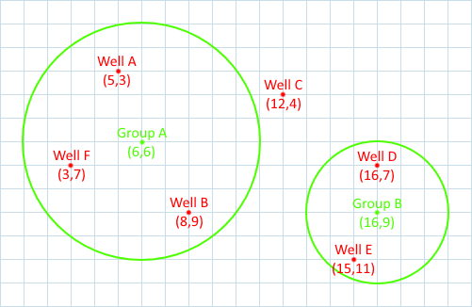

# Requirements

Provide a project or solution compatible with Visual Studio 2017 or Visual Studio Code, written in C#, containing your implementation of the above design: the source should be of production-quality code and be able to demonstrate sufficient logic for the complete implementation of these objects and their rules. The solution must conform to the requirements; however, you may design the user interface as you see fit. Web, desktop, and console interfaces are all acceptable.

There will be no additional support for answering questions regarding the design criteria. You should ensure that any assumptions or missing information in the design is appropriately recorded.

Please submit your work via email to travis.oconnell@3esi-enersight.com with a zip file attached that contains your project. Do not submit the compiled binaries in order to keep the size of the zip file as small as possible.

In addition, please provide any additional instructions that are required to compile, test, or run your project.